Linux Command List Assessment:

# 20BCE7273 Sahishnu Aprameya

## File and Directory Operations:

1. Ls:



1. Cd:  
   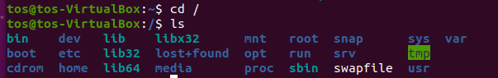
2. Pwd:  
   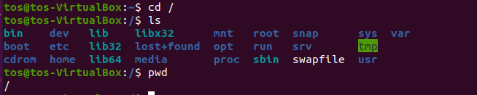
3. Mkdir:  
   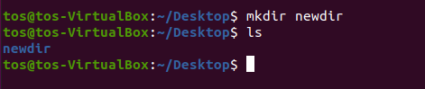
4. Touch:  
   
5. Cp:  
   
6. Mv:  
   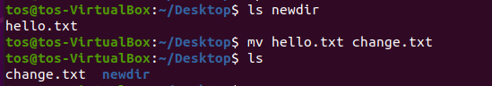
7. Rm:  
   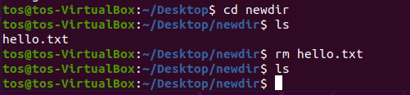
8. Find:  
   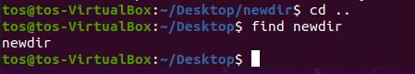

## File Viewing and Editing:

1. Cat:  
   
2. Less:  
     
   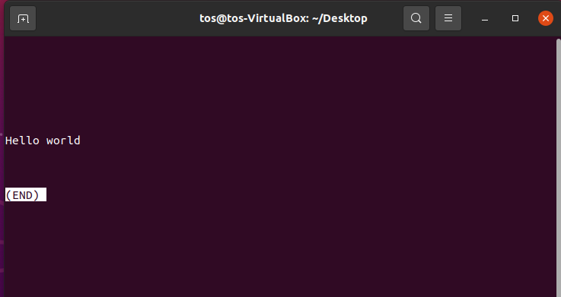
3. Head:  
   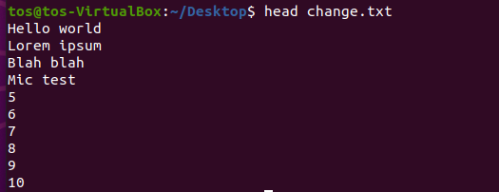
4. Tail:  
   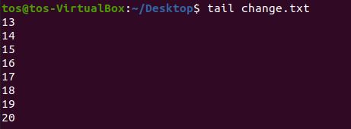
5. Nano:  
     
   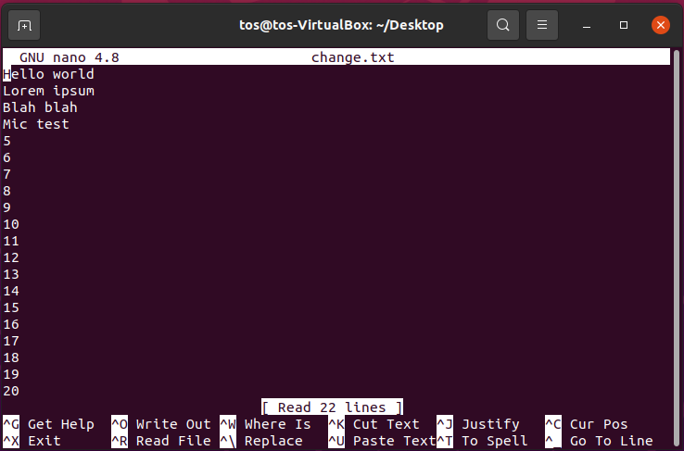
6. Vi/vim:  
     
   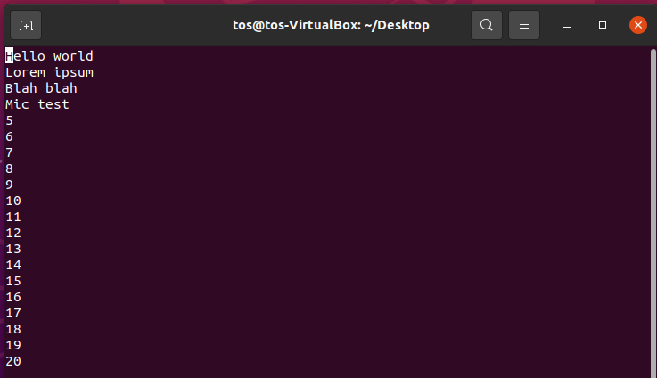

## File Permissions:

1. Chmod:  
   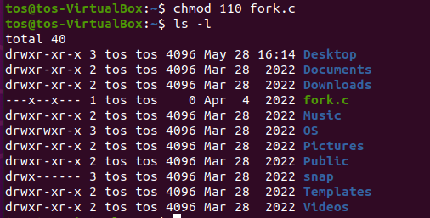

## File compression and Archiving:

1. Tar:  
   
2. Gzip:  
   

## Process Management:

1. Ps:  
   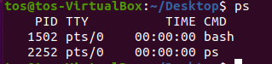
2. Top:  
   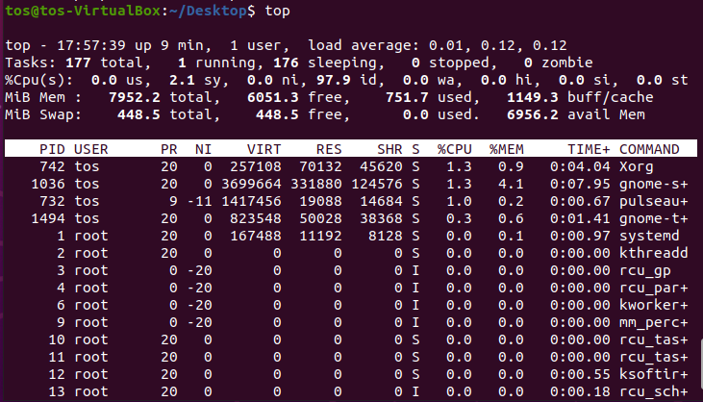
3. Kill:  
   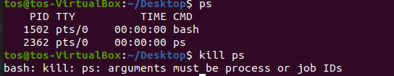

## System Information:

1. Uname:  
   
2. Df:  
   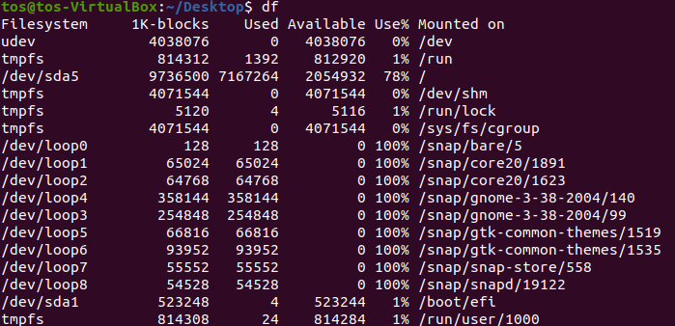
3. Free:  
   
4. Uptime:  
   
5. Who:  
   
6. W:  
   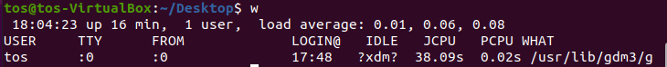

## Networking:

1. Ifconfig:  
   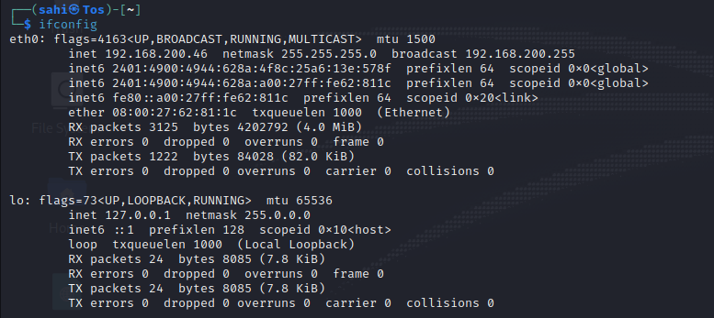
2. Ping:  
   